Module 1

Assignment 1.3
Course: CSD420-340A Advanced Java for Programmers
Prepared By: Mirach Erkol
Date of Report: 3/29/2026

https://github.com/Mikey5007/csd-420.git

1.2 Assignment:
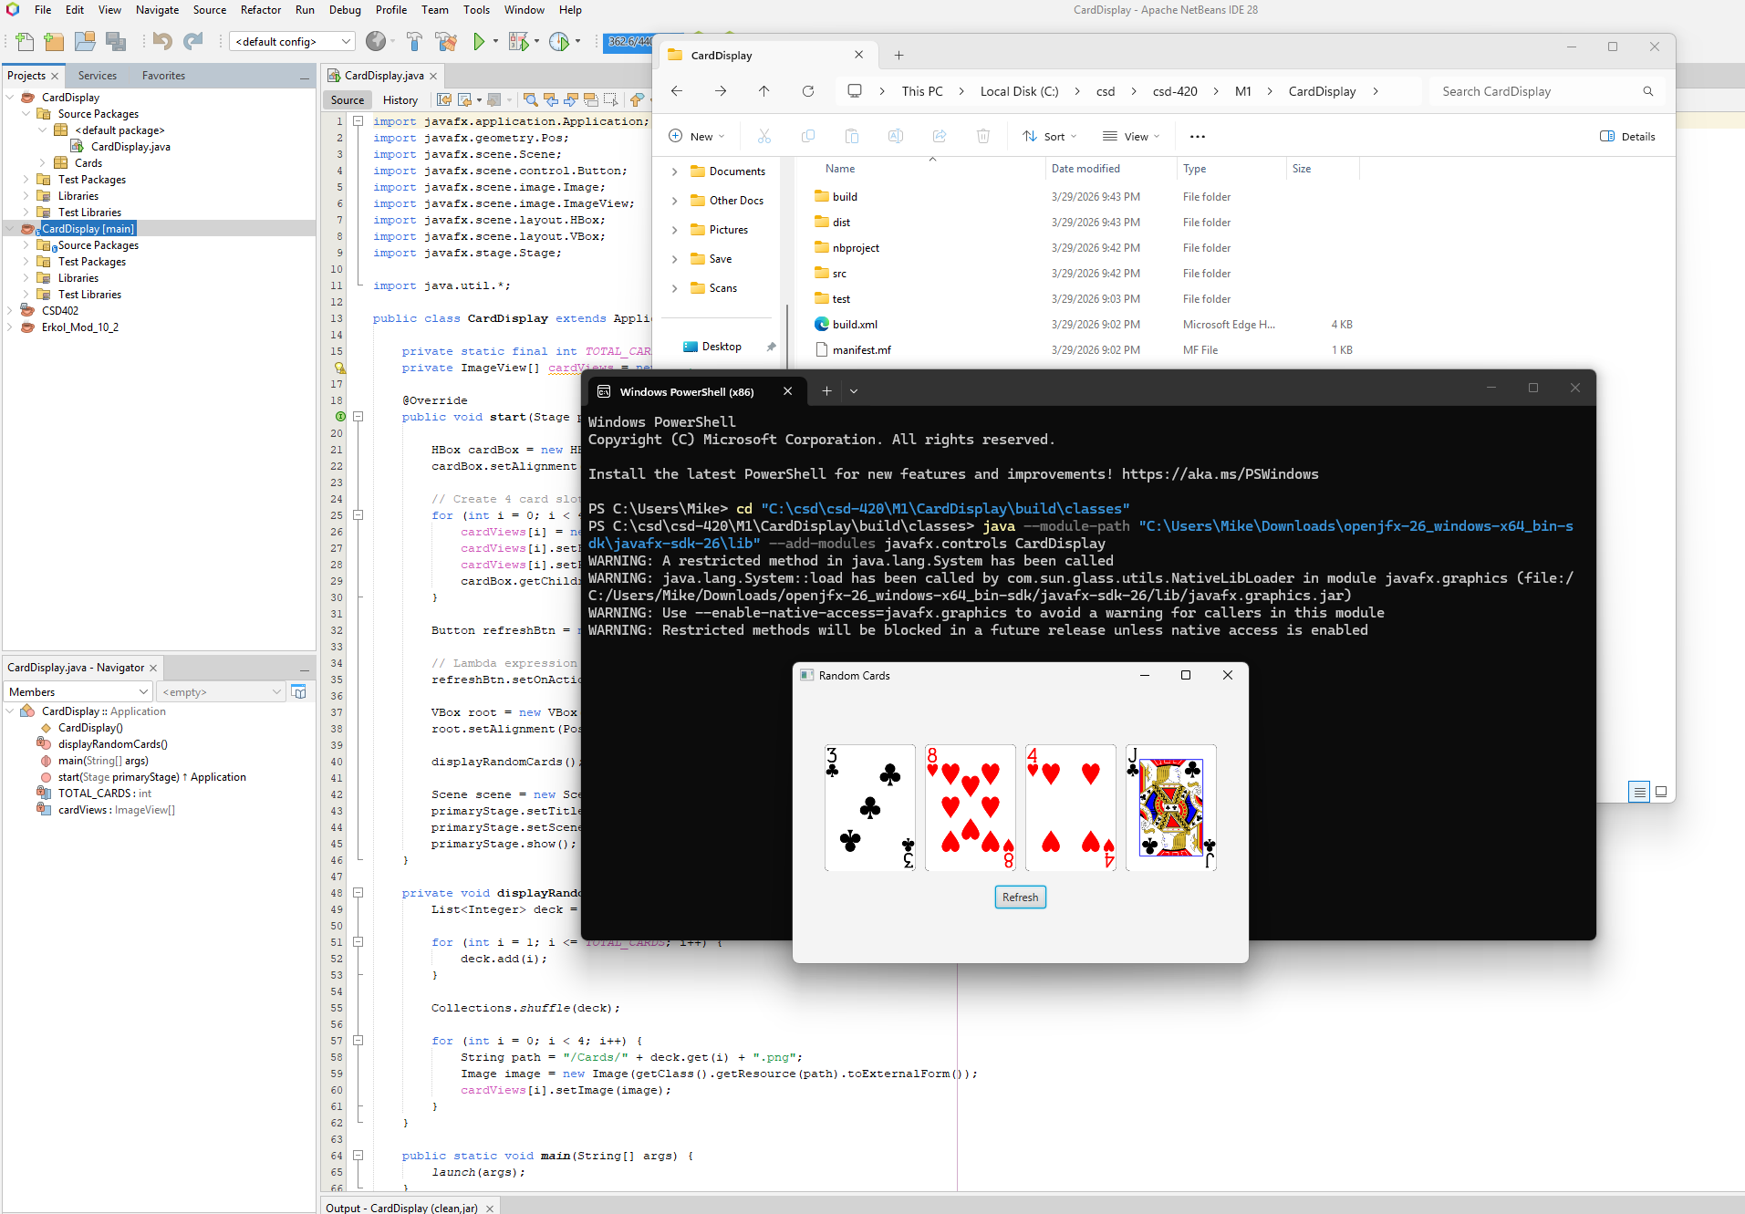

References:

https://github.com/Mikey5007/csd-420.git

